Use of IoT in Quarantined Hotels during COVID-19 and lessons learnt

Abstract
One of the hardest-hit industries globally by the COVID-19 crisis has been the hospitality industry. Government officials across the United Kingdom have converted thousands of empty hotel rooms into quarantine zones (quarantine hotels). The purpose of the quarantine hotel is to keep an individual under observation for 10 days, the standard quarantine, for signs of having COVID-19. This paper investigates how the Internet of Things has helped understand guest behaviour in a quarantined hotel during the COVID-19 pandemic by using WI-FI data analytics and AI CCTV cameras. Overall, it is indicated that A.I. technology which, would help hotels learn guest behaviours and in anticipating the needs of future guests, is inadequately used in the hotels industry. Moreover, A.I. technology would help increase the safety of both guests and employees within the hotels. The data obtained can be fed to health officials to assess changes in conditions, assisting in determining infection rates. Other information can be obtained, such as behavioural trends regarding hygiene. This type of information can be beneficial to the medical community in addressing changes in the COVID-19 pandemic. Furthermore, A.I. technology would be beneficial in allowing for fewer required onsite employees, which would help prevent transmission.

Keywords:, COVID 19, Quarantine Hotel, Cisco Meraki Wi-Fi, CCTV, Data Usage

Introduction

As of September 2020, there have been over 27.4 million COVID-19 cases, where about 18.4 million have recovered, and over 896,000 have died (World Health Organization, 2020). Preventative strategies include frequent hand washing, avoiding face touching, and coughing/sneezing into a tissue (Kishor and Ramhari, 2020). Wearing masks is another tool used in public and crowded places to prevent the spread of disease, as are physical distancing measures (Knell et al., 2020). As the understanding of COVID-19 continually expands using data-driven analytics, safety measures have been changed to meet the new knowledge, such as guiding reopening communities and establishing quarantine hotels to reduce the spread of the virus. Hotels globally introduced covid measures for quarantine hotels;
China's quick response (Q.R.) code system required individuals to fill out a symptom survey and record their temperature, allowing authorities to monitor health and control movement. Some apps even gave specific instructions, such as taking precautions and conducting self-isolation for 14 days. Self-reported surveys such as those used in Q.R. code systems only work when individuals are symptomatic and report their symptoms accurately
South Korea implemented tools for aggressive contact tracing, using security camera footage, facial recognition technology, and mobile phones to provide real-time data and detailed timelines of people's whereabouts. If individuals were close to each other. The application recorded these encounters and stored them in their respective mobile phones for 21 days. If an individual is diagnosed with COVID-19.
In Australia, international travellers were quarantined in hotels on arrival, with travellers from Wuhan quarantined off the Australian mainland. In the new legislation, individuals breaching quarantine will be forced to wear tracking devices, with fines levied for further instances of breaking the restrictions.
Germany had launched a smartwatch application that collected pulse, temperature and sleep pattern data from screening for signs of viral illness. Data from the application were presented on an online, interactive map in which authorities could assess the likelihood of COVID-19 incidence across the nation.
In the USA, a private company has used digital thermometers to collect real-time data on febrile illness clusters. A national study capturing resting heart rate with a smartwatch application could identify COVID-19 emerging outbreaks.
Singapore launched a Tag-Tracing mobile phone application that exchanges short-distance Bluetooth signals when individuals are close to each other. The application records these encounters and stores them in their respective mobile phones for 21 days. If an individual is diagnosed with COVID-19, Singapore's Ministry of Health accesses the data to identify contacts of the infected person. Like South Korea, Singapore has maintained one of the lowest per-capita COVID-19 mortality rates in the world. However Mobile phone solutions for quarantine enforcement can be bypassed if individuals leave their quarantine location without their devices. Singapore was the first country to deploy a national coronavirus-tracing app.
The local authorities say 2.1 million people have downloaded the software, representing about 35% of the population.
Privacy concerns When the Token was first announced in early June, there was a public backlash against the government - something that is a relatively rare occurrence in Singapore.
Wilson Low started an online petition calling for it to be ditched. Almost 54,000 people have signed.

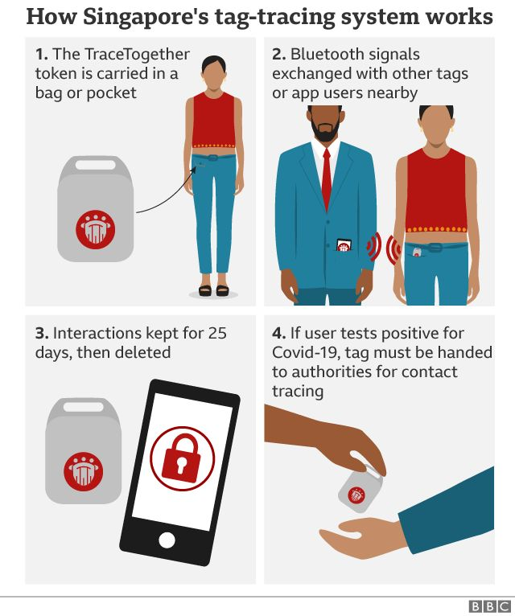
Singapore Tag -Tracing

Kinsa, a San Francisco-based start-up, began selling and donating its smart thermometers eight years before the onset of covid-19. In the race to control the coronavirus, some public health experts have great expectations for a humble tool: a “smart” thermometer that is feeding data about surging fevers into a new online “Health Weather” map of the United States. Especially while diagnostic tests remain scarce, the device may provide early warnings for officials chasing down local outbreaks before the disease can spread. he thermometer is the first and only device you use in the home when illness strikes,

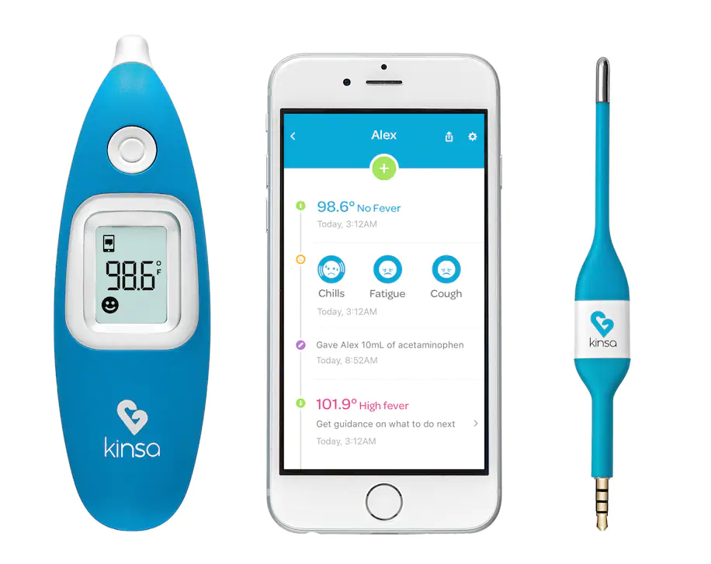

However, behavioural trends vary across hotels, as does the ability of staff members to adequately supervise guests and protect all individuals involved, both internally and externally, because of the massive change in needs when operating a quarantined hotel.
Data were obtained from a 464-bedroom hotel in London Heathrow, designed explicitly for weekend visits, spa visits, and business travellers. Although initially closed as part of the physical distancing requirements, it was reopened as a quarantined hotel. The hotel features complimentary superfast WI-FI that reaches up to 150 Mbps. Data analysis was based, in part, on Cisco Meraki WI-FI network usage from 2019, 2020, and 2021.
As of January 2021, stringent border controls were introduced to protect the U.K. from new variants of Covid in. This meant mandatory quarantine in hotels for British travellers arriving back into the U.K. from a red list of high-risk countries (Department for Transport, 2021). These returning British residents were required to stay in government-approved hotels following strict guidelines to ensure the spread of the Covid virus. Covid tests than needed to be taken on days two and eight of isolation to 'enable authorities to track new cases more effectively'(Department for Transport, 2021).

Cisco Meraki Network WiFi Analytics
A Cisco Meraki Wi-Fi solution is used for guest and staff purposes, one of Cisco Meraki benefits is Location based analytics that displays real-time location statistics to improve customer engagement across sites and is built-in to Cisco Meraki Apps. Data collected by A.P.s are synced with the Cisco Meraki cloud and automatically reported in the dashboard example revealing visitor traffic trends, dwell time. Use of Location Analytics to compare visitor trends between sites or after launching campaigns and to find the effect of actions on visitor dwell time or repeat visit frequency. The Cisco Meraki app can be customised to display data for a specific day, weekend, or even trends over a month
The hotel guest, WiFi connectivity diagram, is shown in figure 1, where : (1) Guest device, (2) WiFi Access point, (3) Access network switch, (4) Core network switch and (5) Core routing switch connecting to the Internet.

5
4
3
2
1
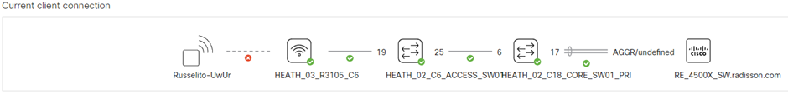
Figure 1

Management data refers to data (such as configuration, statistics, and monitoring) that flows from Meraki devices (such as security appliances, wireless access points, and security) to the Meraki cloud over a secure internet connection. User data refers to user traffic data (internal applications and web browsing). User data does not flow through the Meraki cloud network but, instead, directly flows to their destination on the LAN or across the WAN. By enabling a packet decoder, we can now see further information. A dynamic host control protocol server (DHCP) has allocated an Ip address of 10.1.216.149 to the intelligent device. At this point, we can see the MAC information for further information. (Analysing Wireless Packet Captures, 2020). At this point, the guest is asked to stand in a queue outside a restaurant, heading into a large meeting room for administration purposes. The guest has roamed to access point HEATH_01_STEAK_AND_LOBSTER_Bar_1_C1.

A wireless client has the ability to roam in an area covered by Meraki A.P.s advertising the same SSID, and it will try and associate to the A.P. that provides the strongest signal (Cisco Meraki, 2020) When roaming on a mesh networks, the mesh will make every effort to keep your existing sessions routed through the gateway A.P. on which the session was initiated. This allows application Layer 7 sessions to remain connected. Since there is no guarantee that another gateway will have the same backhaul, changing routes over the mesh for a single session is avoided as much as possible. Newer sessions will be initiated via the current best route to the Internet.

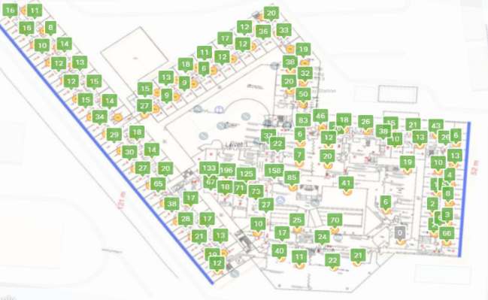
Figure 2: Layout of Hotel floor plan
The following table shows the WI-FI usage in terabytes from 2019 to 2021.
Table 2: Data Usage from 2019 to 2021
 | Jan | Feb | Mar | Apr | May | Jun | Jul | Aug | Sep | Oct | Nov | Dec | Total
2019 | 46.7 | 32.3 | 52.3 | 53.4 | 64.2 | 60.0 | 61.9 | 63.7 | 62.2 | 65.5 | 63.5 | 64.4 | 690.1
2020 | 76.6 | 64.5 | 57.8 | 30.6 | 21.2 | 16.3 | 16.6 | 13.9 | 12.1 | 13.7 | 11.8 | 13.0 | 344.0
2021 | 13.0 | 28.3 | 88.9 | 111.3 | 119.3 | 116.8 | 119.3 | 119.4 | 101.4 | 115.6 | 11.2 | 0.00 | 944.1

As seen in Table 2, data usage changed during the COVID-19 pandemic. From 2019, the total amount of data used is 690.1 terabytes, which is normal WI-FI data usage for hotel guests. However, by April 2020, data usage rapidly changed as stay-at-home orders were issued, prompting the hotel to be closed to all guests and only 37 staff onsite for essential operations purposes and were required to remain onsite. From April 2020 to February 2021, the data usage is attributed to employees. Following government guidelines, on March 3, 2021, the hotel was reopened as a quarantined hotel, and data usage increased significantly due to guests having to quarantine. The following figure displays the data usage from 2019 to 2020.

Figure 11: Data Usage Between 2019 to 2021 & Figure 12
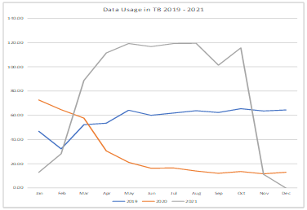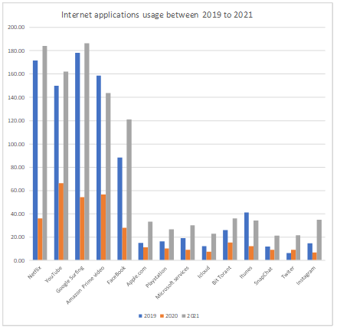

Usage went up dramatically when the hotel was reopened as a quarantined hotel, likely because guests could not leave their rooms. Table 3 below shows application usage from 2019 to 2021.
However, during 2020, there was a considerable drop in usage because of the hotel being closed. As shown below, when reopened as a quarantined hotel, internet usage increased significantly
All data came from the CISCO Meraki dashboard and shows the change in data usage during the pandemic from prior to the pandemic, to closure, to reopening as a quarantined hotel. As seen, there were significant
decreases in data usage, then increases as guests were quarantined in their rooms for the required ten-day period.

CCTV A.I. analytics testing

As artificial intelligence CCTV cameras have become adopted across most industries over the years governments, The term Edge-based A.I. has been incorporated into video surveillance for end-to-end A.I (Hanwha Techwin, 2020) Most security cameras send collected data for analysis to servers, but edge-based A.I. enables the camera to analyse the data first, then send the data analysis to the server, which leads to increased efficiency, decreased time consumption, and decreased server costs required for data analysis (Hanwha Techwin, 2021). A.I. cameras, enabling users to quickly search for specific objects or incidents, with the algorithms even able to recognise if a person is wearing glasses or holding a bag. (Hanwha Techwin, 2021). Generally, when A.I cameras are mounted on ceilings, the recommended installation height is 2 to 3 metres high at an angle of 45 degrees or higher in shown.
We have enabled the following parameters, Object detection, BestShot and Face Mask detection. This features captures events that are triggered when an object is detected wearing a facemask or no mask. The image is in JPEG format and contains only a portion of the area where the target objects are detected. BestShot image data can be transferred to the programs linked to the camera for them to utilize.

Face Mask detection A.I

By enabling A.I features, The following attributes have been captured, male, adult, wearing a blue jumper, blue trousers and face mask. The image can be mailed, saved and searched from a central server more so the ability to search attributes by jumper, colour adult wearing face mask. BestShot has captured by the most confident object among all objects.

Figure 14: A.I features being enabled
a. Objection detection with Best Shot using attributes  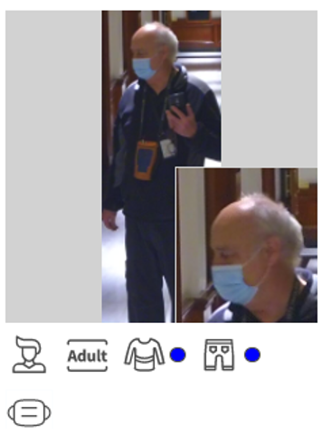 | b. Objection detection with BestShot Jpeg image displays in more detail.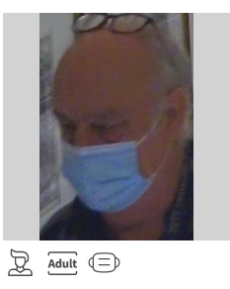 | c. Female detected  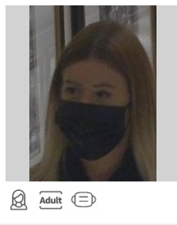 | d. No facemask detected with no attributes  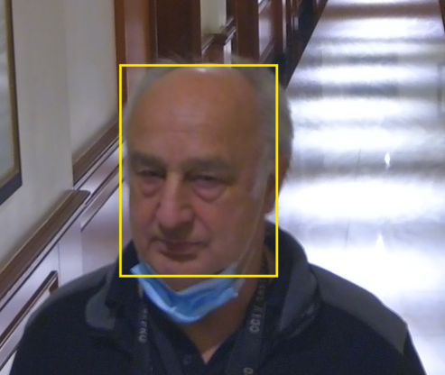
Event log information:
Figure 14a-c : [2021-01-14 14:52:28] [MaskDetection] [[Channel:1] FaceMaskDetection Detected]
Figure 14 d : [2022-01-14 16:22:210] [MaskDetection] [[Channel:1] FaceMaskDetection No Mask]
Object detection A.I

Figure 15 and Figure 16: Displays person wearing a mask with a yellow square box alongside with an orange rectangle, furthermore, identified other people in the image. Object detection algorithms produce a list of object categories in the image along with an axis-aligned bounding box indicating the position and scale of every instance of each object category. The data generated creates meaningful intelligence to help better understand people in images.

Figure 15: Object detection with facemask detection  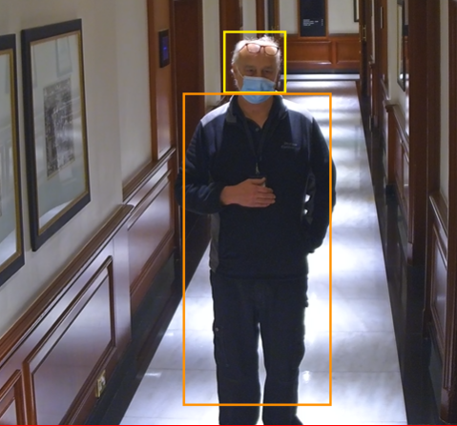 | Figure 16: Object detection with facemask detection, other people been identified in background  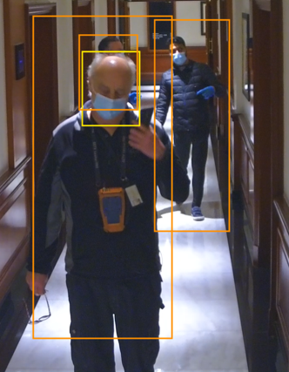

Lessons Learnt

The Cisco Meraki network intelligence platform provided a dashboard view of the hotels portfolio's network health across applications, including Internet, Voice, Guest Service, IoT, Bandwidth per user has also increased because of the guest experience changing amid COVID-19. We attribute this to guests spending more time in video applications utilizing streaming services and high bandwidth activity such as video calls.
limited Internet of Things technology is available in hotels furthermore the cost of A.I cameras are expensive depending the type of A.I capabilities. We found that people complied with the 2 meter distance directives when these directives were first introduced, but that the level of compliance started to decline soon after. We also find that violation of the 2 meter distance directives is strongly associated with the number of people observed in the hotel As a result, there is no monitoring available to assess the consumption of water or heating. There are limitations for controlling the television through intelligent apps, as opposed to using a remote control, as traditionally done. There is a lack of video conferencing facilities and capabilities in most hotels. Most hotels have no air quality monitoring capabilities, nor are there technologies to assess how often sanitiser is used, such as through a digital sanitiser pump. Since all restaurants were closed down in the hospitality industry, there were approximately 100 deliveries to hotels, increasing the risk of COVID-19 transmission.
Overall, it is indicated that A.I. technology is inadequately used in the hospitality industry and, mainly, within hotels. The use of this technology would help hotels learn guest behaviours and assist the hotel in anticipating the needs of future guests. Moreover, A.I. technology would help increase the safety of both guests and employees within the hotels.

Conclusions
There are recommendations for installing Wisenet cameras to ensure that A.I. performance is reliable (Hanwha Techwin, 2021). It can be expected that if the camera is installed for reliable A.I. camera detection activities, it is recommended that all cameras be installed at a 45-degree angle, regardless of height or type of installation (Hanwha Techwin, 2021)at a minimum height of 3 metres at a 45-degree angle, objects at least one metre away and taller than 170 centimetres can be recognised (Hanwha Techwin, 2021). Moreover, detection is possible until over two-thirds of the object is visible to a distance of 5.6 metres from the camera (Hanwha Techwin, 2021).. This creates a side view, enhancing the analytic ability of the camera of the results.
A.I. technology could help quarantine hotels ensure the safety of their guests and employees in multiple ways. Moreover, data can be fed to health officials to assess changes in conditions, assisting in determining infection rates. Other information can be obtained, such as behavioural trends regarding hygiene, such as determining the number of times hand sanitiser is used or washing hands in public areas. This type of information can be beneficial to the medical community in addressing changes in the COVID-19 pandemic. Moreover, A.I. technology would be beneficial in allowing for fewer required onsite employees, which would help prevent transmission.

References

Analyzing Wireless Packet Captures (2020) "Analyzing Wireless Packet Captures - Cisco Meraki."
Breier, M. et al. (2021) "The role of business model innovation in the hospitality industry during the COVID-19 crisis," International Journal of Hospitality Management, 92. doi:10.1016/j.ijhm.2020.102723.
Cheng, K.K., Lam, T.H. and Leung, C.C. (2020) "Wearing face masks in the community during the COVID-19 pandemic: altruism and solidarity," The Lancet [Preprint]. Lancet Publishing Group. doi:10.1016/S0140-6736(20)30918-1.
Cisco Meraki (2020) Cisco Meraki. Available at: https://documentation.meraki.com/General_Administration/Other_Topics/Management_traffic_for_Cisco_Meraki_devices.
Common Travel Area (2021) Common Travel Area. Available at: https://www.gov.uk/government/news/all-uk-travel-corridors-temporarily-suspended-to-protect-against-new-international-variants (Accessed: January 11, 2022).
Covid-19 Travellers (2021) "Covid-19 Travellers." Available at: https://www.bbc.co.uk/news/uk-55995645 (Accessed: January 11, 2022).
Department for Transport (2021) "All U.K. travel corridors temporarily suspended to protect against new international variants - GOV.UK."
Farboodi, M., Jarosch, G. and Shimer, R. (2021) "Internal and external effects of social distancing in a pandemic," Journal of Economic Theory, 196. doi:10.1016/j.jet.2021.105293.
Forenbacher, I. et al. (2021) "Throughput of an ieee 802.11 wireless network in the presence of wireless audio transmission: A laboratory analysis," Sensors, 21(8). doi:10.3390/s21082620.
Hanwha Techwin (2020) “10. Face Mask Detection_200731_EN.”
Kishor, R.S. and Ramhari, B.M. (2020) "Introduction to Covid-19," Research Journal of Science and Technology, 12(4), pp. 338–345. doi:10.5958/2349-2988.2020.00051.0.
Knell, G. et al. (2020) "Health behavior changes during covid-19 pandemic and subsequent 'stay-at-home' orders," International Journal of Environmental Research and Public Health, 17(17), pp. 1–16. doi:10.3390/ijerph17176268.
Loey, M. et al. (2021) "A hybrid deep transfer learning model with machine learning methods for face mask detection in the era of the COVID-19 pandemic," Measurement: Journal of the International Measurement Confederation, 167. doi:10.1016/j.measurement.2020.108288.
Managed Quarantine Service (2021) Managed Quarantine Service Welcome Pack for Students arriving in the United Kingdom. Available at: https://www.gov.uk/government/publications/managed-quarantine-what-to-expect/managed-quarantine-what-to-expect.
Sikali, K. (2020) "The dangers of social distancing: How COVID-19 can reshape our social experience," Journal of Community Psychology. Wiley-Liss Inc., pp. 2435–2438. doi:10.1002/jcop.22430.
What Is a Fat Finger Error (2021) What Is a Fat Finger Error? Available at: https://www.investopedia.com/terms/f/fat-finger-error.asp.
World Health Organization (2020) World Health Organization. Available at: https://covid19.who.int.

