Software guidance for ‘Modeled Optimal Gait’

Developed by Dr Izzy Moore for a project funded by the British Association of Sport and Exercise Science.
Contents
Installation 3
Start-up 3
Calculating the optimal model 4
Modeled figure output 4
Modeled data output 5
Interacting with the software 6
Changing data used by the model 6
Changing the type of polynomial 7
Contact details 8
References 8

Installation
There are three ways to install this software. If you have MATLAB you should download and save the .mlappinstall file. Using this file will mean the software is run through MATLAB.
If you do not have MATLAB you should have two options:
- Download the standalone_web file, this will require a runtime file to be downloaded from MATLAB (online). The file will download the runtime file in the background. This installation file is much smaller than the standalone_mcr.
- Download the standalone_mcr and install it on your computer. This package already includes the runtime file and may take some time to download and install due to its size.
Run the .exe file and save the software in your desired location.

Start-up
To run the software locate it in your chosen location. It will be named ‘ModeledOptimalGait’. Select ‘application’ and then select ‘ModeledOptimalGait’ by double-clicking. This will open the software. It will take a few seconds.
Example data has been included in the table provided from data derived from Moore and colleague’s (2019) study. The biomechanical gait data is in the first column. The physiology data is in the second column. The third column identifies which row of the data represents the self-selected (habitual) gait.

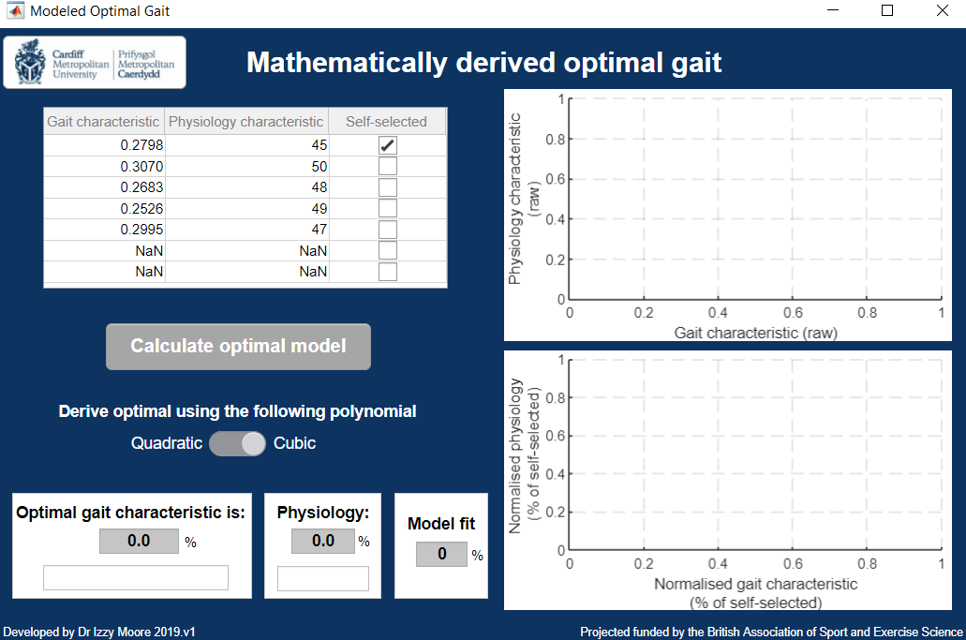

Calculating the optimal model
Click the ‘Calculate optimal model’ button to process the data in the table. The first time you press this button it will take a few seconds to plot the data and perform the calculations.

Modeled figure output
Once the button has been ‘clicked’ the following figures will be populated:
- All raw data will be plotted in the top figure, with the fitted curve
- All normalised data (to the self-selected row) will be plotted in the bottom figure, with the fitted curve
Normalised data
Raw data

Both the measured data (inputted by the user;) and the predicted optimal data () are represented in the figures. Additionally, the fitted curve is shown by the black line.
The value of zero in the bottom figure, normalised data, represents the self-selected gait characteristic and its respective physiological characteristic.

Modeled data output
Once the button has been clicked the following outputs will be populated:
- The optimal gait characteristic will be computed and displayed
- The minimum physiology characteristic will be computed and displayed
- The model fit (explained variance) will be computed and displayed

The optimal gait characteristic and minimum physiology characteristic are represented as a percentage of the data in the self-selected row. The direction that the optimal gait characteristic deviates from the self-selected gait characteristic is identified under the percentage.
The model fit is the R² value, known as the amount of explained variance the fitted curve provides for the given data points.

Interacting with the software
Users can interact with the software by inputted data, changing the self-selected row and changing the number of degrees used to compute the fitted curve.

Changing data used by the model
Spatiotemporal gait data can be inserted into the software (e.g. ground contact time, stride frequency and stride length). All of these gait characteristics have been shown to display a mathematical optimal relationship with physiological characteristics. Heart rate or oxygen consumption data should be used to represent the physiology characteristic.
A maximum of seven rows of data can be inserted. If less than seven are needed use ‘NaN’ or a value of zero. The algorithm will ignore these rows when the ‘calculate optimal model’ button is clicked.
Users can select which row represents the self-selected gait using the third column. Ensure that only one row is selected. Warning messages will be displayed if no row or more than one row is selected.

Changing the type of polynomial
The number of degrees used to compute the curve fit can be changed by the user. Early research used a quadratic (two degrees) polynomial (Cavanagh & Williams, 1982), whilst recent work has used a cubic (three degrees) polynomial (Moore et al., 2019).
The cubic polynomial is the default option and is recommended based on the potential asymmetrical responses to gait manipulation, which it will be able to accommodate. Toggling between cubic and quadratic can be undertaken by the user to compare the affect it has on the model fit.
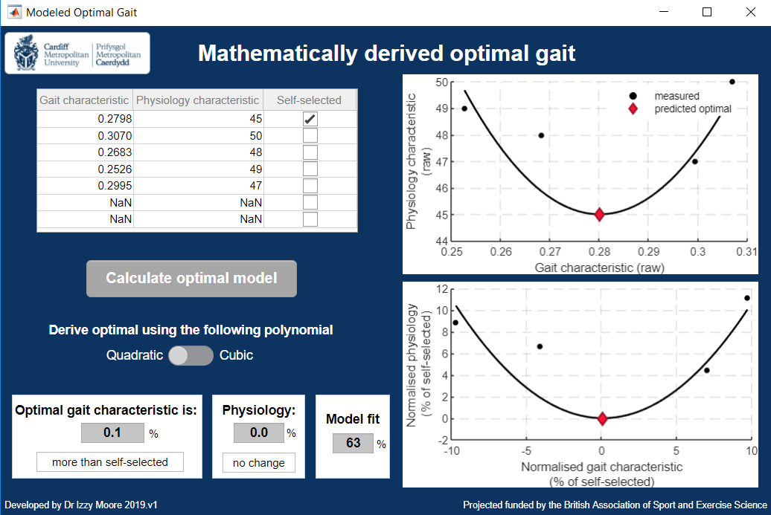

Contact details
For questions regarding the software and associated research please contact Dr Izzy Moore:
Email address: imoore@cardiffmet.ac.uk
Dr Moore received the British Association of Sport and Exercise Science Early Career Researcher and Practitioner Award (2018).

References
Cavanagh, P. R., & Williams, K. R. (1982). The effect of stride length variation on oxygen uptake during distance running. Medicine and Science in Sports and Exercise, 14, 30-35.
Moore, I. S., Ashford, K. J., Cross, C., Hope, J., Jones, H. S. R., & McCarthy-Ryan, M. (2019). Humans optimise ground contact time and leg stiffness to minimise the metabolic cost of running. Frontiers in Sports and Active Living. DOI: 10.3389/fspor.2019.00053.

